St John Bosco RC Primary School
With Jesus in our hearts we love, pray, learn and play

SEND Policy May 2023

Our school Mission Statement states, “With Jesus in our hearts, we love, pray, learn and play.” Our belief in the unique dignity of the human person made in the image and likeness of God underpins our school community.

Our School Vision
Our ambitions for our children are that:
- They have a deep and strong understanding of their faith.
- Their wellbeing (both physical and mental) is supported and safeguarded.
- Their academic potential is fulfilled.
- They have a love of learning and skills which will carry them into the future.

We expect children, staff, parents, volunteers and the learning community to share our vision.

Rationale
St John Bosco School is committed to providing an appropriate and high quality education to all. We believe that all children, including those identified as having special educational needs have a common entitlement to a broad and balanced academic and social curriculum, which is accessible to them, and to be fully included in all aspects of school life.

This policy describes the way we meet the need for children who experience barriers to their learning, which may relate to sensory or physical impairment, learning difficulties or emotional or social development and explains how we strive to develop an environment where all children can flourish and feel safe.

We recognise that pupils learn at different rates and that there are many factors affecting achievement, including ability, emotional state, age and maturity. We are particularly aware of the needs of our Foundation Stage and Key Stage 1 pupils, for whom maturity is a crucial factor in terms of readiness to learn. We believe that many pupils, at some time in their school career, may experience difficulties which affect their learning, and we recognise that these may be long or short term.

At St John Bosco, we aim to identify these needs as they arise and provide teaching and learning contexts which enable every child to achieve his or her full potential.

Aims

At St John Bosco, there is a culture of high expectation for all pupils including those with SEND. Regardless of their particular needs, all children are provided with inclusive teaching, which will enable them to make the best possible progress and feel that they are a valued member of the wider school community. We expect that all pupils with SEND will meet or exceed the high expectations we set for them against national data and based on their age and starting points.

We will use our best endeavours to give pupils with SEND the support they need, whilst having access to a broad and balanced curriculum. Working in partnership with families, it is our aim that pupils will become confident individuals able to make a successful transition on to the next phase of their education.

Objectives

- To ensure the Special Educational Needs and Disability Act and relevant Codes of Practice and guidance are implemented effectively across the school.

- To ensure equality of opportunity for and to eliminate prejudice and discrimination against children with special educational needs. The Equality Act link is below.

https://www.gov.uk/guidance/equality-act-2010-guidance

- To continually monitor the progress of all pupils, to identify needs as they arise and to provide support as early as possible.

- To provide full access to the curriculum* through differentiated planning by class teachers, SENDCO and support staff as appropriate.

(*Except where disapplication, arising from a Statement occurs, disapplication is very rare, and we aim to offer the full curriculum to all our pupils).

- To provide specific input, matched to individual needs, in addition to differentiated classroom provision, for those pupils recorded as having SEND.

- To ensure that pupils with SEND are perceived positively by all members of the School community, and that SEND and inclusive provision is positively valued and accessed by staff and parents/carers.

- To involve parents/carers at every stage in plans to meet their child’s additional needs.

- To involve the children themselves in planning and in any decision making that affects them where appropriate

- To ensure parents know the Manchester Council Local Offer details. https://hsm.manchester.gov.uk/kb5/manchester/directory/localoffer.page?localofferchannel=0

Key Roles and Responsibilities

The SENDCO – Special Educational Needs and Disability Coordinator has day-to-day responsibility for the operation of SEND policy and co-ordination of specific provision made to support individual pupils with SEND, including those who have EHC plans. The SENDCO is a member of the senior leadership team. The SENDCO is Mrs L Pearson. The SEND Learning assistant is Mrs R Armstrong.
Mrs L Pearson is currently studying to complete the NASENDCo award. (National Award of Special Educational Needs and Disability co-ordination)

The designated person for Looked After Children (LAC) is the SENDCO, Mrs L Pearson.

SEN Governor: The SEN governor is Mrs Lorraine McCauley. She has responsibility for monitoring policy implementation and liaising between the SENDCO and the Governing Body. She can be contacted via the school email address. contact@st-johnbosco.manchester.sch.uk

Safeguarding Team:
Designated Safeguarding Lead (DSL) is Mrs L Pearson, Headteacher (Acting). Other staff with safeguarding responsibility and DSL qualification are Mrs F Lovell (Acting Deputy Head Teacher) and Mrs M. Webster, (Learning Mentor).

Definition of SEN and Disability (SEND)

The definition for SEN and for disability comes from the SEND Code of Practice (2014). This states:

SEN: A child or young person has special educational needs if he or she has a learning difficulty or disability which calls for special educational provision to be made for him or her. A learning difficulty or disability is a significantly greater difficulty in learning than the majority of others of the same age. Special educational provision means educational or training provision that is additional to, or different from, that made generally for others of the same age in a mainstream setting in England.

Disability: Many children and young people who have SEN may have a disability under the Equality Act 2010 – that is ‘…a physical or mental impairment which has a long-term and substantial adverse effect on their ability to carry out normal day-to-day activities.’

Identification of Needs
The identification of SEN is embedded in the whole school process of monitoring the progress and development of all pupils. We recognise the benefits of early identification and making effective provision in improving the long-term outcomes for children with SEN. The purpose of identification is to work out what action the school needs to take, not to fit the pupil into a category. It is also important to identify the full range of needs, not simply the primary need of an individual pupil.

The Code of Practice refers to four broad areas of need:

Communication and interaction - these children have a difficulty in communicating with others. This may be because they have difficulty saying what they want to, understanding what is being said to them or they do not understand or use social rules of communication. For example, children with Autistic Spectrum Conditions (ASC), including Asperger’s syndrome, are likely to have particular difficulties with social interaction. They may also experience difficulties with language, communication and imagination, which can affect how they relate to others.

Cognition and learning - children with learning difficulties learn at a slower pace than their peers, even with appropriate differentiation. Learning difficulties cover a wide range of needs from moderate learning difficulties (MLD) to children with profound and multiple learning difficulties (PMLD). Specific learning difficulties (SpLD), affect one or more specific aspects of learning, such as dyslexia, dyscalculia and dyspraxia.

Social, emotional and mental health difficulties - children may experience a wide range of social and emotional difficulties which manifest themselves in many ways. These may include becoming withdrawn or isolated, as well displaying challenging, disruptive or disturbing behaviour. These

behaviours may reflect underlying mental health difficulties such as anxiety or depression, self-harming, eating disorders or physical symptoms that are medically unexplained. Other children may have disorders such as attention deficit disorder (ADD), attention deficit hyperactive disorder (ADHD) or attachment disorder.

Sensory and/or physical needs-some children require special educational provision because they have a disability that prevents or hinders them from making use of the educational facilities generally provided. Many children with vision impairment (VI), hearing impairment (HI) or a multi-sensory impairment (MSI) will require specialist support and /or equipment to access their learning.

A Graduated Approach to SEN Support

How the school identifies special educational needs.

A process of on-going teacher assessments and termly pupil progress meetings with the leadership team identifies those pupils making less than expected progress given their age and individual circumstances. The school’s first response is high quality targeted teaching by the class teacher. Where progress continues to be less than expected, the class teacher will discuss their concerns with the SENDCO. (See Appendix A SEND Process at St John Bosco).

The teacher and SENDCO will consider all of the information gathered from within the school about the pupil’s progress, alongside the views of parents/carers and pupil. During this stage extra teaching or interventions may be put in place as a pupil’s response to such support can help to identify their particular needs. Particular care is taken when identifying and assessing SEN for children whose first language is not English.

Where pupils have higher levels of need, and with parental permission, the school may to seek advice from external agencies. These agencies include:

- Educational Psychology Service (EPS)
- Speech and Language Therapy Service
- Behaviour Support Service (BSS)
- Physical/Sensory Support Service
- Educational Welfare Team
- Children’s Services
- School Nurse/Paediatric health team
- Child and Adolescent Mental Health Service (CAMHS)

If the support needed can be provided by adapting the school’s core offer then a child might not be considered SEN or placed on the SEN register. If the support required is different from or additional to what is ordinarily offered by the school, the child will be placed on the SEN register at SEN Support. The school will then seek to remove barriers to learning and put effective special educational provision in place. This begins a cycle of assess, plan, do, review with the child/young person at the centre of the process.

Each child will have a “One Page Profile” (see Appendix B) which is easily accessible in the classroom so that any adults or visitors to the classroom can easily be made aware of a child’s unique needs. A Learning Support Plan (LSP) will also be created which is reviewed and shared with parents three times a year. This document states the targets a child is working towards and what is in place to support them. (See Appendix C). This plan will be created on the Provision Map software. Where a child and family would benefit from co-ordinated support from more than one agency an Early Help Assessment may be used to identify help required and to prevent needs escalating.

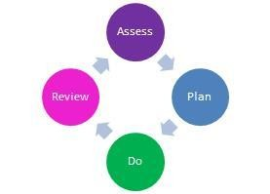

The four part cycle:

Assess: We will ensure that we regularly assess all pupils’ needs so that each child’s progress and development is carefully tracked compared to their peers and national expectations. We will listen to the views and experience of parents/carers and the pupil. In some cases we will draw on assessments and guidance from other education professionals e.g. Educational Psychologists (EP) and from health and social services.

Plan: Where SEN Support is required the teacher and SENDCO will put together a plan outlining the adjustments, interventions and support which will be put in place for the pupil as well as the expected impact on progress and outcomes, including a date when this will be reviewed. Targets for the pupil will be shared with her/him using child friendly language and with parents/carers. All staff who work with the pupil will be made aware of the plan.

Do: The class teacher is responsible for working with the pupil on a daily basis. She/he will also liaise closely with TAs or specialists who provide support set out in the plan and monitor the progress being made. The SENDCO will provide support, guidance and advice for the teacher.

Review: the teacher, SENDCO, parent/carer and the pupil, will review the plan, including the impact of the support and interventions, each term. This will inform the planning of next steps for a further period or where successful the removal of the pupil from SEN Support.

This four part cycle through which earlier decisions and actions are revisited, refined and revised with a growing understanding of the pupil’s needs and what supports the pupil in making good progress is known as the graduated approach. It draws on more detailed approaches and more specialist expertise in successive cycles.

Requesting an Educational, Health and Care (EHC) Statutory Assessment

A small number of pupils, whose needs are complex and long term, may require a greater level of support than that provided at SEN Support from the school’s own resources. These children may need additional adult support, intervention or resources in order to access learning. These children may need their timetable adapting, a specific workspace etc. If children need something that is additional to and different from other children, there may be a need to apply for additional funding. For these pupils a request will be made to the local authority to conduct a statutory assessment of education, health and care needs. The SENDCO will pull together all the documents and evidence that is needed to apply and will consult with the parents. There will be a TAC meeting immediately before the documentation is sent the LA. This may result in an Education, Health and Care (EHC) plan being provided. This brings together the child’s health and social care needs as well as their special educational needs.
EHCP’s are reviewed each year at the child’s Annual Review. Parents/carers and pupil involvement in the process
We believe in a person centred approach to information gathering and the cycle of assess, plan, do, review. Termly reviews and target setting meetings are planned to coincide with parents’ evenings where possible. All parents will be invited to a LSP review meeting. Targets are shared with pupils and successes are celebrated.

SEN Provision

SEN support can take many forms. This could include:

- an individual learning programme
- evidence based interventions
- extra help from a teacher or a learning support assistant
- making or changing materials, resources or equipment
- working with a child in a small group
- using specialist equipment (eg coloured overlays, ear defenders)
- observing a child in class or at break and keeping records
- helping a child to take part in the class activities
- making sure that a child has understood things by encouraging them to ask questions and to try something they find difficult
- helping other children to work with a child, or play with them at break time
- supporting a child with physical or personal care difficulties, such as eating, getting around school safely, toileting or dressing
- access to a nurture group
- additional pastoral support

Managing the needs of Pupils on the SEN Register

Each pupil with SEND is unique and their plan is tailored to meet their particular needs. Plans are reviewed termly with parents and pupils. Decisions regarding the level of support provided are needs led, working within the constraints of the school budget.

The class teacher is responsible for:

- the progress and development of all pupils including those with SEND
- ensuring the plan is implemented in the classroom
- regular liaison with parents and the SENDCO
- effective deployment of additional adults
- Identifying on class planning the provision they are making for pupils with SEND
- Supporting the SENDCO in the writing and reviewing of targets for pupils with SEND
- Planning appropriate work which will support the child and move them forward with their targets.

Special Needs Assistants are responsible for:

- ensuring that day to day provision is in place for the pupils they support
- implementing agreed strategies and programmes, and advice from specialists.
- record keeping
- resources
- maintaining specialist equipment
- regular communication with class teacher and SENDCO

The SENDCO is responsible for:

- the SEND policy and its implementation
- co-ordinating support for children with SEND
- updating the SEND register and maintaining individual pupil records
- monitoring the quality of provision and impact of interventions
- attending network meetings and updating staff
- referrals to and liaison with outside agencies
- line managing TAs with responsibility for SEND
- liaising with and advising staff
- maintaining regular liaison with parents/carers
- co-ordinating annual reviews
- supporting staff in identifying pupils with SEND.
- mapping provision throughout the school
- maintaining links and information sharing with receiving schools Criteria for removing pupils from the SEND Register
When a child has made sufficient and sustained progress towards achieving their personal targets and it is felt that they are able to maintain this with quality first teaching, they may be removed from the SEN register. The school will continue to monitor pupils recently removed from the register to ensure good progress is maintained. Any decision made about a child being removed from the SEND register will be discussed with parents.

Additional support for parents/carers and children

We provide additional support in the following ways:

- the headteacher and SENDCO operate an open door policy for parents/carers seeking support and advice.
- the dedicated SEND Governor who is available as a contact point
- individual arrangements can be made for phased entry into Reception class
- additional time and special arrangements for SATs
- additional support for transition between classes
- a transition group for vulnerable Y6 pupils transferring to secondary school
- inviting the SENDCO of the receiving secondary school to the final Annual Review in year 6.
- Coffee mornings for parents of SEND children to provide support for each other and opportunity to talk to SENDCo, SEND learning assistant & Learning Mentor
- Ad hoc support for children, eg phonecalls/emails home to advise of unexpected changes in school, eg changes to timetable / supply teachers etc.

Supporting pupils at school with medical conditions

Support is put in place so that pupils with medical conditions have full access to education, including school trips and physical education. Where it is the case that a medical condition meets the criteria of disability the school will comply with its duties under the Equality Act 2010.
Reasonable adjustments will always be made to promote access to all areas of the school curriculum for pupils with a disability, eg: an extra adult to accompany a child on a school trips/residentials. Specific staff have training to support particular needs, eg: technical knowledge to maintain auxiliary aids and equipment or managing diabetes. All staff are trained in supporting children with Asthma and in the use of Epi pens.
All staff working with a child with medical needs are given NHS information about the condition and ways to support them. Staff are expected to read this information and inform the SENDCO when they have done so.

Monitoring and evaluation of SEN

The head teacher and the leadership team regularly monitor and evaluate the quality of provision for all pupils. The school aims to use interventions in school that have proven outcomes and are evidence based. The impact of SEND provision on the progress and outcomes for children on the SEND register is measured through:

- analysis of pupil tracking data and test results at pupil progress meetings
- progress against national data and based on their age and starting points.
- interventions baseline and exit data
- progress against individual targets
- pupils’ work and interviews
- conversations with parents

The SENDCO maps provision for each class and decisions are made as to whether specific interventions are proving to be effective in terms of impact, time spent on them and the finance used in providing them. Each year we review the needs of the cohort and if necessary make changes to our provision.

The SEND Governor is responsible for:

- monitoring the effective implementation of the SEND policy
- liaising termly with the SENDCO
- reporting to the governing body on SEND
- ensuring that pupils with SEND participate fully in school activities Training and development
Training needs are identified in response to the needs of pupils currently on the SEND register.

The SENDCO attends network meetings to share good practice with colleagues in the Manchester area and keeps up to date with SEND developments.

Storing and Managing Information
Pupil records and SEND information may be shared with staff working closely with SEND pupils to enable them to better meet the individual child’s needs. We are grateful to parents for their information sharing and openness and respect their confidentiality. All data is stored securely.
Pupil SEN files are kept in a locked filing cabinet and are stored on our secure CPOMs system. Individual SEND files are transferred to receiving schools when pupils leave St John Bosco.

Complaints

We urge parents/carers with any concerns regarding the SEND policy or the provision made for their child at St John Bosco to speak to us as soon as possible. In the first instance, please speak to the class teacher or the SENDCO. If parents/carers feel their child's needs are still not being met they should make an appointment to see the deputy head teacher and if parents/carers still feel that their child’s needs are still not being met, then an appointment with the head teacher should be made.

Access to this policy
You can get a copy of this policy via our school website. A hard copy is available on request at the school office.

Contacts

SENDCo
Mrs L Pearson
0161 7407094
St John Bosco Primary School Hall Moss Rd
M9 7AT

SEND Governor
Mrs L. McCauley
contact@st-johnbosco.manchester.sch.uk
For letter contact please use: F.O.A Mrs L. McCauley, school address, marked private and confidential.

Links to other Policies
This policy should read in conjunction with:
-SEND school information report
-Privacy Notice
-Anti-bullying policy
-Accessibility policy (TBC)
-Complaints policy
-Data protection policy (TBC)
-Medical policy (TBC)
-Safeguarding policy

All of these are available on our school website http://www.st-johnbosco.manchester.sch.uk/page/policies/14917

Policy Agreed: May 23
To be reviewed: May 2024

Appendix A
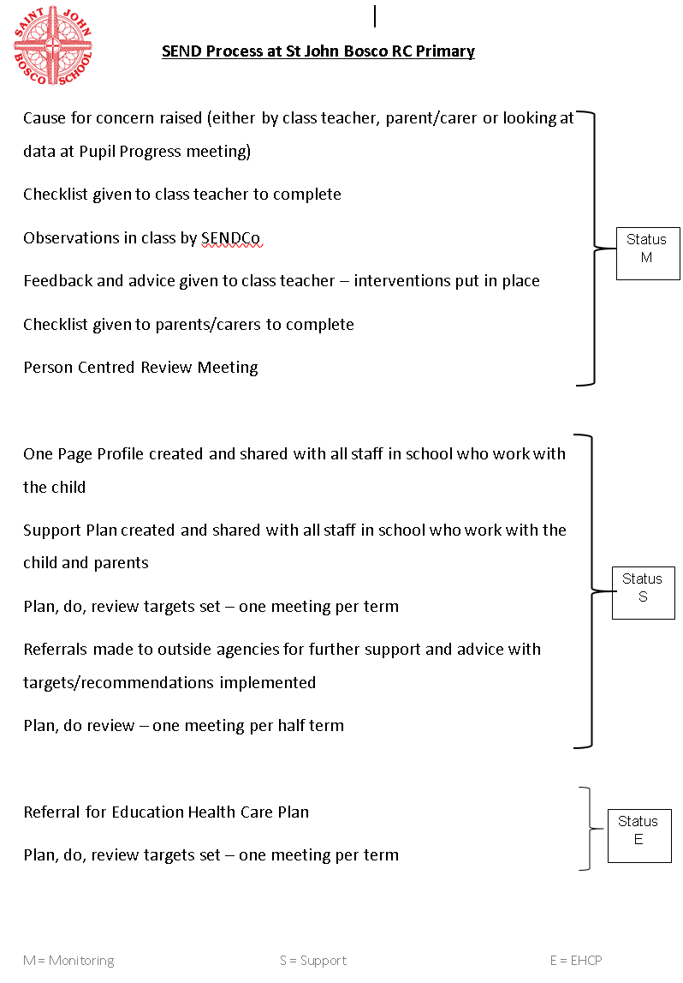

Appendix B – Example of One Page Profile

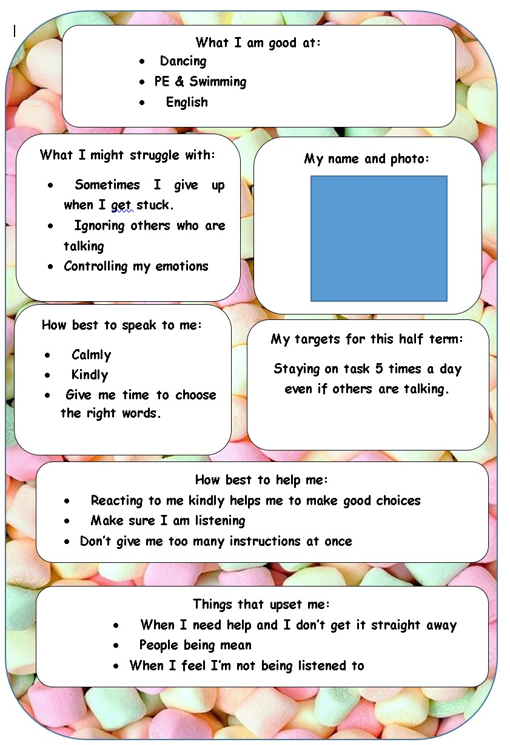

Appendix D – Further reading
The following documents have informed this guidance which parents may find helpful:

- Special educational needs and disability code of practice: 0-25 years https://www.gov.uk/government/publications/send-code-of-practice-0-to-25

- Special educational needs and disability: a guide for parents and carers https://www.gov.uk/government/publications/send-guide-for-parents-and-carers

- Supporting pupils at school with medical conditions https://www.gov.uk/government/publications/supporting-pupils-at-school-with-medical-conditions--3

- Keeping children safe in education https://www.gov.uk/government/publications/keeping-children-safe-in-education

- Equality Act 2010 https://www.gov.uk/guidance/equality-act-2010-guidance

- Manchester City Council Local Offer Website: https://hsm.manchester.gov.uk/kb5/manchester/directory/localoffer.page?localofferchannel
=0

