Friday 3rd May

Dear Parents and Carers,

This term is flying by and I can’t believe it is the bank holiday weekend! So much has been happening this term, if you don't already follow us on Instagram, please scan the QR code below and get looking at all the amazing things we do in school.

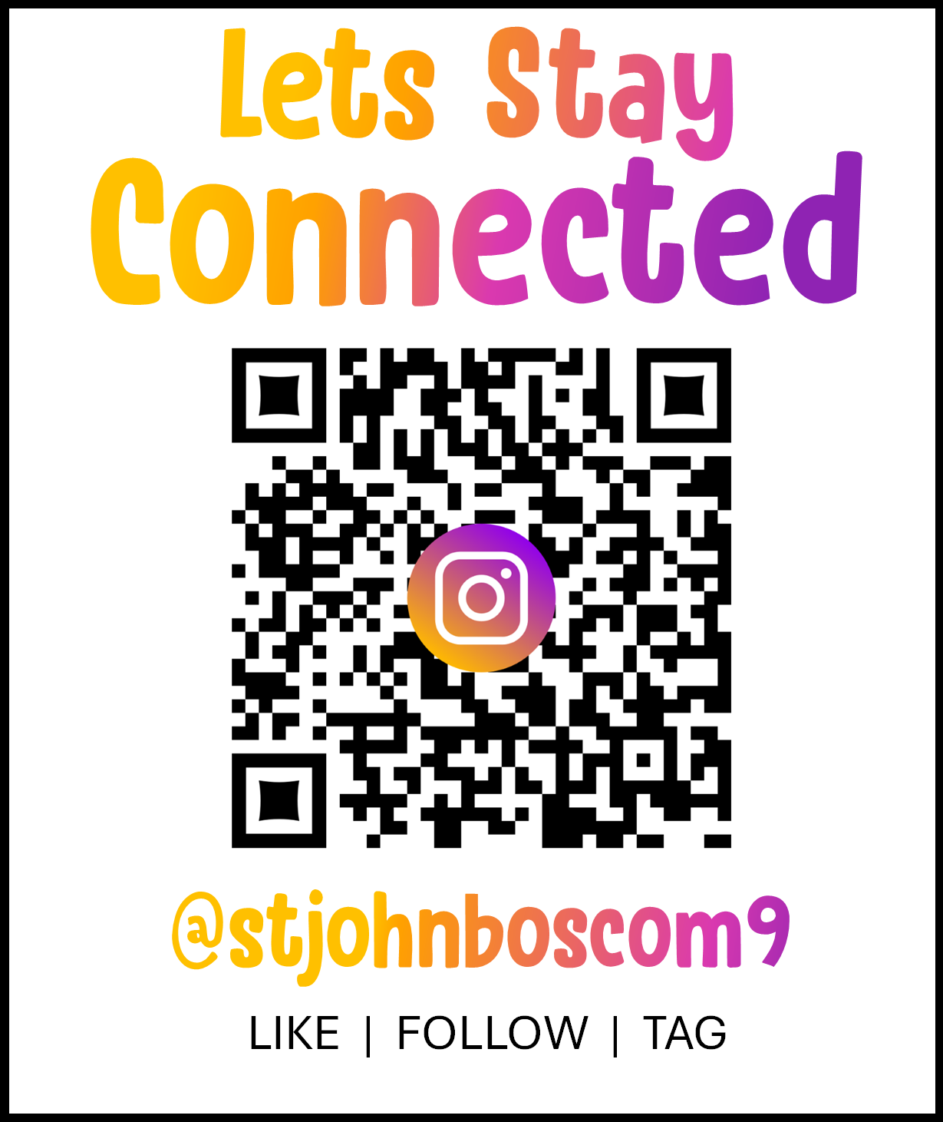

**Family Race Night-** Saturday 4th May 6pm- Please join is at St John Bosco parish hall for a fun night for all the family. We will be supporting virtual horse racing, food and alcohol is available to buy, a sweet stall, a raffle and a gin roll! Please bring your family and friends and support this fun fundraising event and help raise some money for school.

**Easyfundraising**- Did you know that St John Bosco Primary are registered with Easyfundraising? This is an organisation that raises money for good causes. Easyfundraising partners with over 7,500 brands who will donate part of what you spend to a cause of your choice. This means you can raise money for us every time you get clothes, groceries, takeaways, insurance, school supplies or anything else you might be buying online anyway. It won’t cost you any extra! The cost is covered by the brand you are buying from. Please scan the QR code below and get raising money.



**Masses**- We had a beautiful mass last week, led by Father Clement, with some of our year 5 and 6 pupils reading prayers and a couple of Year 3 children bringing up the offertory. The children were exceptionally reverent and the singing was beautiful. Our next mass is on Thursday 9th May at 9am- we would like our Year 4 and Year 5 parents to come to this one. Other parents will be invited to other masses before the end of the school year.

**Mental Health Awareness week**- Mon 13th- Friday 17th May- We feel very strongly that we equip our children to have strategies to ensure they have good mental health and can recognise when their mental health is dipping. We will be doing different activities in the afternoons across the week, such as ‘walk and talk’, mindfulness, reflection and exercises. The week will finish on the Friday by children and staff wearing green clothes, the colour that is representing mental health during this week.

**Reading**- Please listen to your children reading daily. Teachers have noticed a deterioration in the number of times children are reading during a week. This will affect your children’s confidence and reading fluency. When you are reading with your child, please ask questions about what they have read to check their understanding and ensure they know the meanings of some of the trickier words in the text. The importance of reading for children cannot be underestimated. Reading for pleasure can benefit a child’s education, social and cognitive development, their wellbeing, and their mental health.

**Perfect presentation award**- We have introduced a set of ‘non negotiables’ in our classes to set a standard of presentation for children’s written work and numeracy work. Teachers from Year 1- 6 will choose a child in class who has made excellent effort in their presentation and the child will receive a certificate and a god pen or pencil to use during the week. Please encourage your children with their presentation and handwriting when doing their homework. Thank you.

**Young Carers-** At St John Bosco R.C Primary School we are aware that some of our pupils are young carers. A young carer is a young person aged 18 or under who helps to look after a loved one who has a sickness, illness, a disability, mental health condition, drug, or alcohol problem.

We have several young carers already identified to us in school who benefit from our comprehensive programme of support, and we value and celebrate the important contribution they make to our school community. We will continue to raise awareness of young carers throughout or school, via assemblies and class discussions and other events. Your children will have been in an assemly about this.

If you think your child might be a young carer, please let us know by filling in the google form and returning to school by Friday 24th May 2024. Any information that is given to us will be treated sensitively and no information will be shared without your knowledge.

<https://docs.google.com/forms/d/e/1FAIpQLSdztQQlSZjKzH6zXufC6dkFxT8g4qjBVlfbMVMxY4Okw6Qa9A/viewform?usp=sf_link>

**Dates for your diary...**

Fri 3rd May- Young Carers assembly for children. Information going home regarding this.

Sat 4th May- Family Race Night – Parish Hall – An exciting family night out with a bar, food and lots of virtual horse races! Many prizes to be won! Send in your envelope with your money and the name of the race, horses or jockey you are sponsoring.

Monday 6th May- SCHOOL CLOSED- BANK HOLIDAY

Thursday 9th May- Mass at 9AM - Year 4 and 5 parents invited

Fri 10th May- 9am- ‘Supporting your child with anxiety’ talk by Healthy Schools Manchester. Please complete the google form below and come along.

<https://docs.google.com/forms/d/1xvsQxH7BFcOybdMPKdvCZMUN65cFPYff9yO-OTL_WX4/edit>

Fri 10th May- PTA meeting 3.15pm- Summer fair planning meeting

Monday 13th-16th May- KS2 SATS week

Mon 13th- Fri 17th – Mental Health Awareness week

Tues 14th May- EYFS open evening for new parents to Reception and nursery classes 4pm-6pm

Friday 17th May- Pentecost party day

Monday 20th-22nd May- Year 6 Robinwood residential visit

Friday 24th May- Sports day- children only

Friday 24th May- Break up for the Whit holidays for 2 weeks

Monday 10th June- Back to school

**Parents speaking to teachers**- Communication is really important to us. If you would like to speak to a class teacher about any issues concerning your child, please make an appointment to see the class teacher. Please do not try to discuss issues when you are dropping your child off or picking your child up. The teacher needs to ensure the class's safety and they cannot do this if they are having conversations while meeting and greeting children or making sure they are going home with the right adults. Thank you for your support with this.

**Car parking**- Please can I remind parents about parking in appropriate and suitable places. We are regularly getting complaints from neighbours about people parking across their gates or in the bus stop area or in a dangerous manner. Thank you for your support with this.

**Attendance-** If your child is poorly please call or email the office before 8.45am to let us know. Please provide appointment letters if you are taking your child out of school for medical appointments.

**School Milk** – If you wish your child to have school milk, please register at [www.coolmilk.com](http://www.coolmilk.com/)

**Payments to school** – Please can parents make sure they are up to date with their payments to school for dinner money, breakfast club, afterschool club and the Robinwood residential.

Thank you for your continued support of your children and our lovely school.

Thank you to everyone who has emailed into school or passed their congratulations to me for being appointed the role of permanant headteacher, it means so much to me. I am proud to have been given this opportunity and lead this fantastic school full of lovely children, parents and staff.

With love and prayers,

Mrs Pearson