Friday 21st June

*With Jesus in our hearts, we love, pray, learn and play*

Dear Parents and Carers,

Thank you to all the parents who came to our amazing art gallery today in the school hall. During our Art Festival this week staff and children have had a really creative time producing fantastic art work and everyone has really enjoyed it. It was so lovely to see so many parents and children walking around and talking about their work. Thank you to those who wrote positive comments about the work.

We have also had sports day today which was also a huge success- the children loved the variety of activities and sports that they took part in. We are considering how we can have parents watching as well next year in the safest and most comfortable way for the children.

Our Instagram page all the fantastic activities your children have been doing in school. Please scan the code below and take a look- its the best way to look at what is going on in our classes.

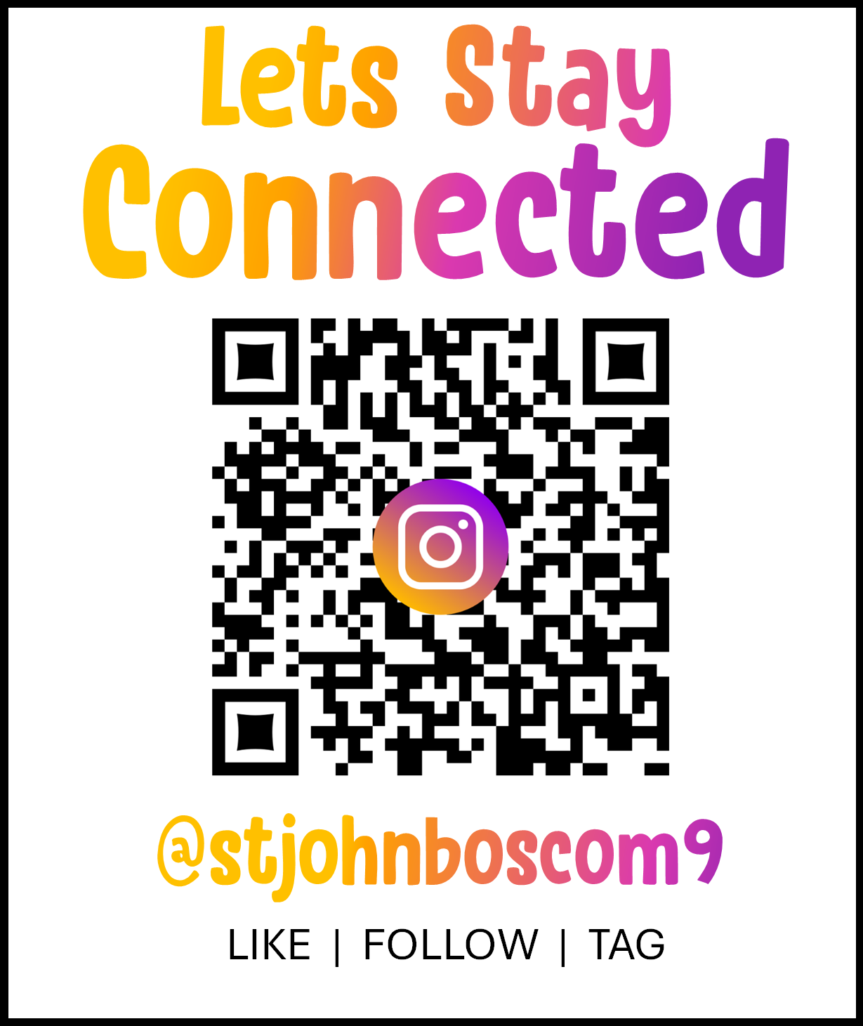

**Tests and Assessments**

This is a term when many tests and assessments are carried out across all year groups. Year 1 and some of Year 2 have already done their Phoncis Screening Check, the Year 4 children have taken their Multiplication Times Check. Both year groups have worked really hard to do their best in theses 'Department for Education' compulsory tests.

All other classes are doing 'inhouse' assessments in the next couple of weeks.

The staff are currently working hard on writing the end of year reports for your children, which you will recieve in the final week of term.

**Bag2School**

Thank you to every one who brought clothes in for Bag2School- we rasied £136 for school fund.

**Father’s day stall**

Thank you very much to the PTA who made the Father's day presents. It is such a joy watching the children choosing presents, especially with siblings, while they discuss and think about what their dad would like best!

**Summer fair**

Thank you so much for all your donations of chocolate and bottles for the fair. Please have a look and see if you have any pre-loved teddies for our teddy tombola, bring them in next week asap please. If any of you work for a company that could donate a prize for the raffle we would be very grateful- please let me know as soon as possible. If anyone has a small business and you would like a stall at the fair, its £20 and a donation to the raffle, again, let me know this week.

If you can help with any preperation with the fair or could help on a stall please let me know- we are short of parental help! We have a small but brilliant group of parents who help but we still need more. Thank you!

**Easy Fundraising**

Did you know that St John Bosco Primary are registered with Easyfundraising? This is an organisation that raises money for good causes. Easyfundraising partners with over 7,500 brands who will donate part of what you spend to a cause of your choice. This means you can raise money for us every time you get clothes, groceries, takeaways, insurance, school supplies or anything else you might be buying online anyway. It won’t cost you any extra! The cost is covered by the brand you are buying from. Please scan the QR code below and get raising money.



We are beginning to recieve some money through this so thank you to those parents who have signed up already.

**Anxiety workshops**

Year 6 are currently receiving workshops from a school nurse to explain anxiety and give them tips and strategies of how to manage anxiety. We have chosn to do this at a time where the children will be feeling anxious about their transition to high school. The first session went really well.

If your child is struggling with anxiety please let school know so we can try to support them.

**Young carers**

Thank you to the parents who have responded to our request to let school know if you think your child is a young carer. We have been working with all the children in school about what a young carer is. We have now been awarded the 'Young Carers in Schools' Award.

**Punctuality**

One day last week we had 37 children arrive after register time. This is unacceptable. Punctuality is extremely important. When your child arrives late, they are missing learning time, they have to walk into a classroom where all the children have already strated working and most children find this embarrassing. They have then missed the teaching and instructions for the work and don't know what to do, which is stressful for them. It is the worst way for a child to start their school day. Please ensure your child is on the playground and entering the building on time and through the boor they should be.

**Our gates open at 8.35am, the doors open at 8.40am. The gates close at 8.45am sharp. The children are being registered at 8.45am**. This term we will start doing occasional ‘late gates’ where staff will be recording the time of lateness and asking you to provide a reason for your lateness. Your child will then receive a late mark. The Local Authority Attendance team are aware of our punctuality issues and will be supporting us with thsi.

**Reading**

Please listen to your children reading daily. Teachers have noticed a deterioration in the number of times children are reading during a week. This will affect your children’s confidence and reading fluency. When you are reading with your child, please ask questions about what they have read to check their understanding and ensure they know the meanings of some of the trickier words in the text. The importance of reading for children cannot be underestimated. Reading for pleasure can benefit a child’s education, social and cognitive development, their wellbeing, and their mental health.

**Parents speaking to teachers**

Communication is really important to us. If you would like to speak to a class teacher about any issues concerning your child, please make an appointment to see the class teacher. Please do not try to discuss issues when you are dropping your child off or picking your child up. The teacher needs to ensure the class's safety and they cannot do this if they are having conversations while meeting and greeting children or making sure they are going home with the right adults. Thank you for your support with this.

**Attendance-** If your child is poorly please call or email the office before 8.45am to let us know. Please provide appointment letters if you are taking your child out of school for medical appointments.

**School Milk** – If you wish your child to have school milk, please register at [www.coolmilk.com](http://www.coolmilk.com/)

**Payments to school** – Please can parents make sure they are up to date with their payments to school for dinner money, breakfast club and afterschool club.

**Dates for your diary**

Monday 24th June- 3.15pm- PTA- carrying out jobs/ activities needed for Summer fair- please come along!

Monday 24th June- Year 6 boys football team playing at the Moston Football tournament at FC United

Wednesday 26th June- Year 1 visit to Mossely Heritage museum- if you have not yet completed the permission form, please do so and pay school either on school gateway or cash by 4pm on Monday 24th June.

<https://docs.google.com/forms/d/1QNY4Q3kx1qUmeDqWYcWXEFntw-dLbxGTXAabdHs-nWE/edit>

Friday 28th June- Own clothes day for chocolate for the Parish fair.

Saturday 29th June- Parish fair at St John Bosco parish hall 1pm- 3pm.

Monday 1st July- Transition day- Children moving up to their next class for the morning.

Thurs 4th July- School closed-polling day

Fri 5th July- Summer fair 3.15pm- 5.00pm

Thurs 11th / Fri 12th July- Dogs Trust visitor talking to all classes

Friday 12th July- Diabetes charity day- wear blue for £1

Tuesday 15th July- Choral speaking festival

Wednesday 17th - Summer Reading Challenge assembly

Fri 19th July- SJB Festival day- £5 per child.

Last year the school went to the beach for the day - you paid £10 each and the school heavily subsidised the cost of the trip so we could go. This year, due to the cost of living crisis and school finances we are doing something different.

We are having a circus skills workshop for each class, a drumming workshop, sports activities and music. The children will get a wrist band, an ice cream, drinks and we will have a picnic outside. Each class will have a theme to dress up and will parade to the other classes. The theme for your child will be sent to you in the next week. This fill in the google form and pay your £5 either by school gateway or cash to the office.

<https://docs.google.com/forms/d/1du93TwHzHybrPYldHofY_vWCMQIrhj8HHtz79BYUEc4/edit>

Tues 23rd July- Year 6 leavers mass

Weds 24th July- Year 6 leavers assembly

Weds 24th July- Break up for Summer 1.30pm

Thank you for our continued support of your children and our lovely school.

With love and prayers,

Mrs Pearson